Here is a **step-by-step detailed explanation** of every component in the DCGAN (Deep Convolutional Generative Adversarial Network) model, explaining the **purpose, importance, and generalization** to work with any **random dataset.**

**1. Importing Necessary Libraries**

**Explanation:**

* **TensorFlow & Keras:** These are the deep learning libraries used to build and train neural networks.
* **Adam Optimizer:** This optimizer is critical for stabilizing GAN training by adapting learning rates dynamically.
* **BatchNormalization, Conv2DTranspose, etc.:** These layers form the core architecture of the **generator and discriminator.**
* **Matplotlib:** Used for **visualizing images** generated by the GAN.
* **Pathlib:** For handling file paths effectively.

**2. Set Dataset Path and Data Augmentation**

**Explanation:**

* **Data Augmentation:** Adds small variations (flipping, rotation, zoom) to increase the dataset’s diversity.
* **Pathlib:** Helps manage file paths for portability across systems.

**3. Load and Preprocess the Dataset**

**Explanation:**

* **Dataset Loader:** Loads images into batches of size 32, resized to 64x64.
* **Normalization:** GANs perform better when input data is scaled to [-1, 1].

**4. Define Helper Function to Plot Images**

**Explanation:**

* **Image Plotting:** Visualizes real images to ensure data loading and augmentation are correct.
* **Convert Back:** Converts images from [-1, 1] to [0, 255] for display.

**5. Implement Spectral Normalization Layer**

**Explanation:**

* **Spectral Normalization:** Prevents weight explosion by controlling the spectral norm of layer weights.

**6. Build Generator Model**

**Explanation:**

* **Generator:** Converts random noise to an image using transposed convolutions.
* **LeakyReLU:** Helps avoid dead neurons during training.
* **Tanh Activation:** Scales output to [-1, 1].

**7. Build Discriminator Model with Spectral Normalization**

**Explanation:**

* **Discriminator:** Tries to distinguish between real and fake images using convolutional layers.
* **Spectral Normalization:** Ensures stable training.

**8. Compile the GAN Model**

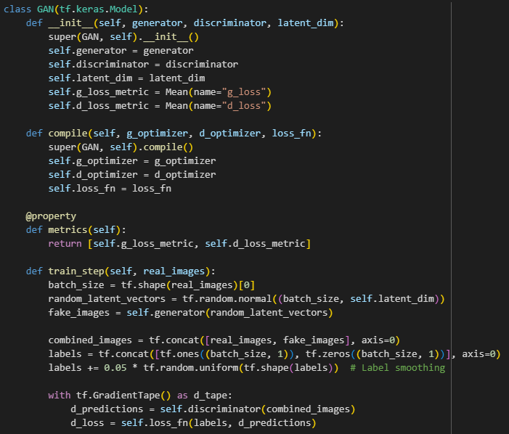

**9. Train the GAN**

**10. Generate and Plot Images**

**11. Define Evaluation Metrics**

Since GANs generate images, traditional loss metrics are not enough to assess model quality. We’ll use Inception Score (IS) and Frechet Inception Distance (FID) to evaluate the image quality and diversity.

**Evaluation Metrics:** Inception Score (IS) and Frechet Inception Distance (FID)

**Explanation:**

* **Inception Score (IS):** Measures the quality and diversity of generated images by predicting classes with an InceptionV3 model.
* **Frechet Inception Distance (FID):** Measures similarity between real and generated image distributions by comparing their feature embeddings.

**12. Save and Load Models**

Saving the trained models ensures that you can reuse them without retraining.

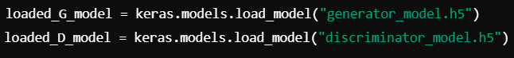

**Explanation:**

* Saves the weights and architecture in .h5 files.
* Allows reloading the models for inference or further training.

**13. Hyperparameter Tuning**

Tuning hyperparameters such as learning rates, batch size, and latent dimension is essential for stable training. Use Keras Tuner to perform a grid search or random search.

**Explanation:**

* **Random Search:** Searches across different hyperparameters (latent dimension, learning rates).
* **Keras Tuner:** Automates hyperparameter tuning to optimize model performance.

**14. Early Stopping and Checkpointing**

Implementing early stopping and model checkpointing helps prevent overfitting and saves the best model.

**Explanation:**

* **Model Checkpoint:** Saves the best model during training.
* **Early Stopping:** Stops training if the validation loss doesn't improve for 5 epochs.

**15. Generate New Images for Inference**

**Explanation:**

* **Generate and Plot:** Creates new images from random noise using the trained generator.

**16. Full Model Training Pipeline**

**Explanation:**

* **Training Loop:** Trains the GAN for 50 epochs with a time tracker.
* **Sample Image Generation:** Displays images after each epoch to monitor progress.

**17. Conclusion**

**This complete code includes:**

1. Training a GAN with Spectral Normalization and adaptive optimizers.
2. Evaluation metrics (IS and FID) for assessing generated image quality.
3. Hyperparameter tuning using Keras Tuner.
4. Early stopping and checkpointing to save the best model.
5. Saving/loading models for reuse or inference.

This approach ensures a robust and efficient GAN pipeline for generating high-quality anime faces, with proper evaluations and optimized hyperparameters.